Whitelist a device in Scale/Acumera
Scenario: FC is emailing because their device or server is offline.

Note: One of the most frequently reported issues comes from the NCR, Acumera/Scale, and Sagenet platforms. Stores may report that their point-of-sale (POS) system or another device cannot access NCR services.

Typical cause:

The device is not registered or whitelisted in Acumera, Acuvigil, or Scale. When a device is not recognized by the firewall or network management system, the network automatically blocks it, preventing it from reaching NCR services.

- Verify the offline device (POS, BOH terminal, KDS, etc.).
- Log in to Acumera/Acuvigil/Scale.
- Use the search bar on the right to search for the specific franchisee number.
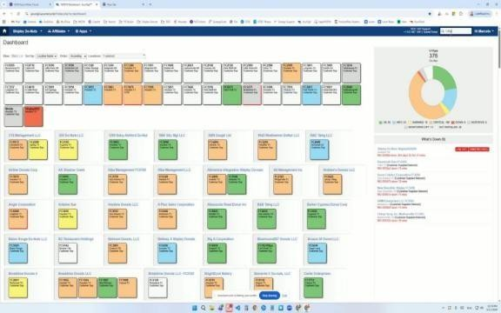

- Go ahead and type in the FC number, and then click on LOCATIONS.
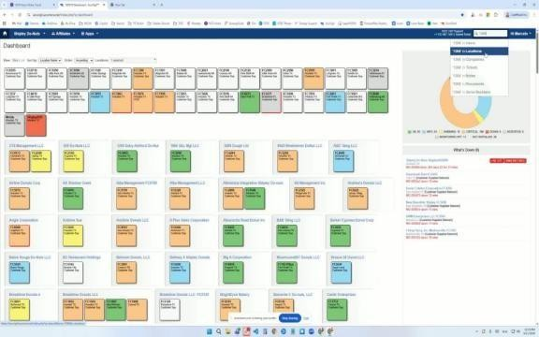

- Under the Devices tab, identify any unregistered devices. Then, go to the REGISTER DEVICES section.
- Add the device to the WHITELIST so that it can connect to the appropriate network.
- Click ADD to register a new device.
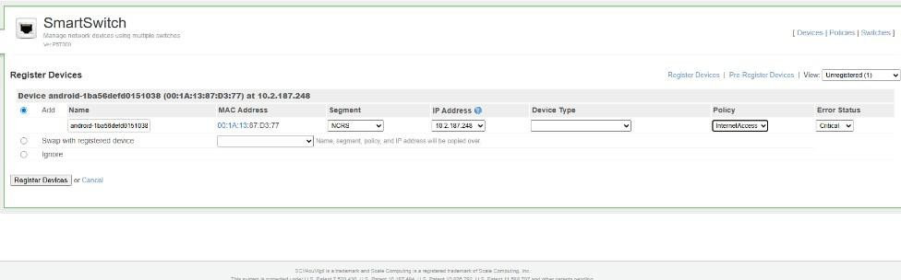
- Select the INTERNET ACCESS policy.
- Click on REGISTER DEVICES to complete the registration.
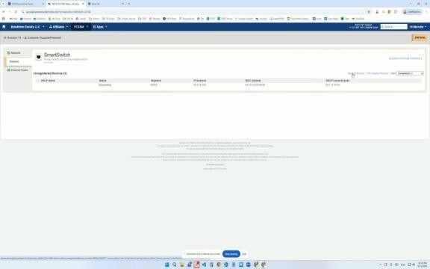

- Make sure the device is listed as REGISTERED.
- Confirm that the device transitions from an offline to an online status.
- Ask the store to test the NCR access again and confirm that the point-of-sale (POS) system is now working correctly.

Registering a device for the POS
Scenario: FC is emailing because they want to register a new POS device.

- Open the app and begin the setup steps.
- Edit the time and choose North America as the region and Central Time as the time zone.
- Tap NEXT.

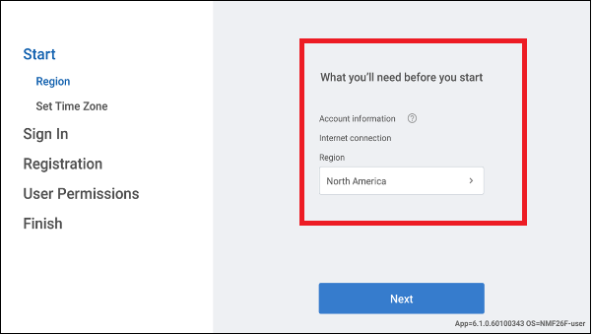

- Enter your username and password registered in Back Office and tap LOGIN.
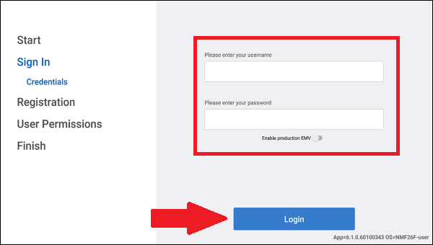

- Tap Select Store option. The Select Store screen appears.
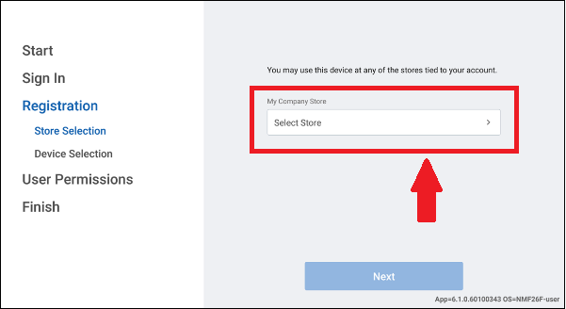

- Select the store tied to your account and tap DONE.
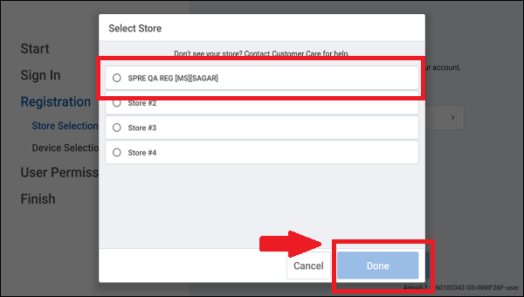

- Tap NEXT.
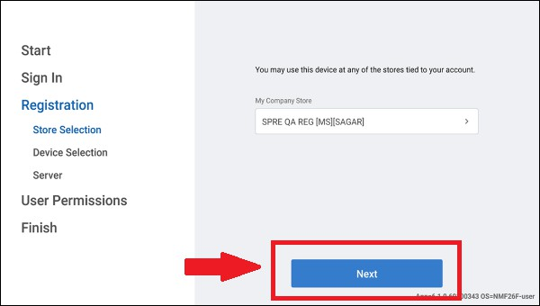

- Enter a unique device name for Descriptive Device Name.

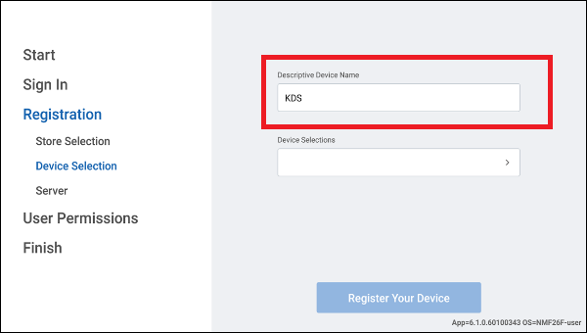

- Tap Device Selections. The Device Selection screen appears.

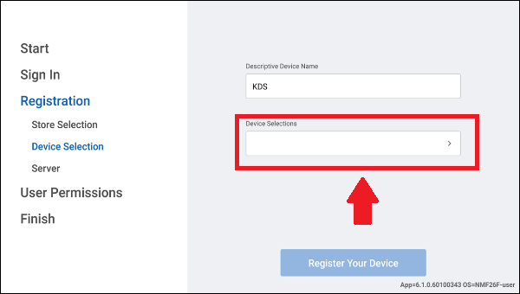

- Choose a station where you wish to register the device and tap DONE.

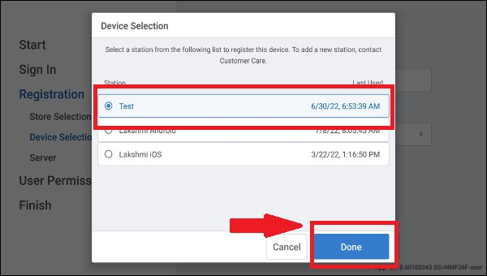

Note: (POS and Kitchen stations are set in Back Office prior to registering your devices. Once complete, the display device shows order information based on the routing configuration for the registered station).

Tap REGISTER YOUR DEVICE.

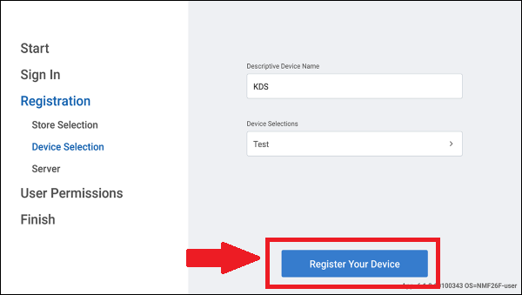

Note: If the customer does not want to register to the store server, he is able to skip and proceed to the next step.

- Type the server IP address or local DNS name or let the app automatically fetch the server
and tap Connect.
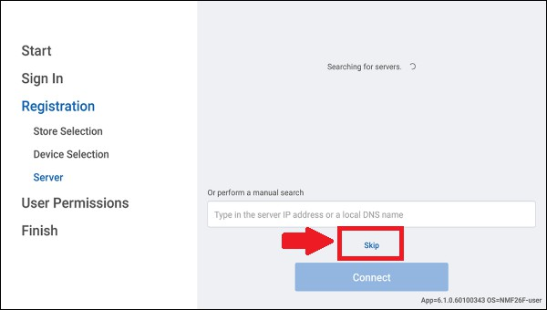

- Tap ALLOW PERMISSIONS.

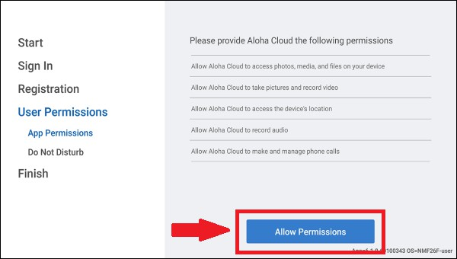

- Tap Allow for each permission requested. (toggle)
- Only enable Aloha Cloud.
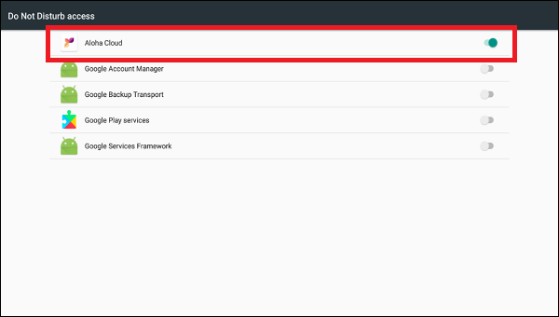

- Tap NEXT.
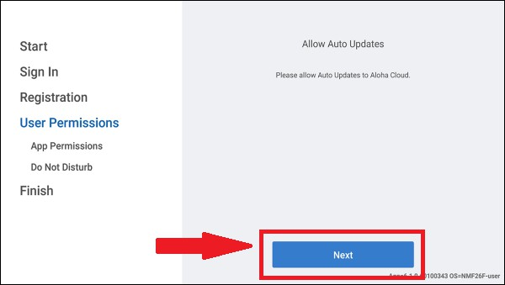

- Tap OK.
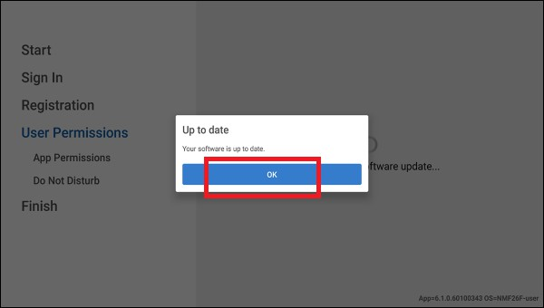

- Tap CONTINUE to complete the configuration.

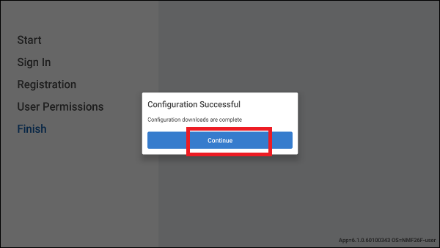

- The POS configuration is now complete. Next, we need to configure the receipt printer, kitchen printer, and cash drawer.

Configuring the receipt printer:
Scenario: The FC needs help configuring the receipt printer.

- Log into the AX5 point-of-sale system with your PIN.
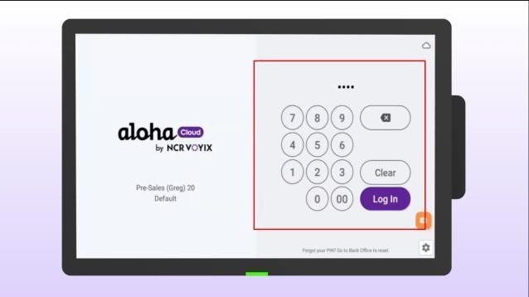
- Click the menu in the top left corner of the screen.
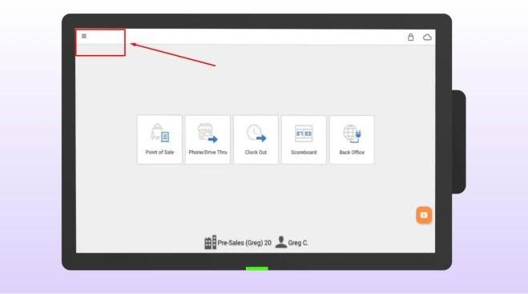
- Select SETTINGS.
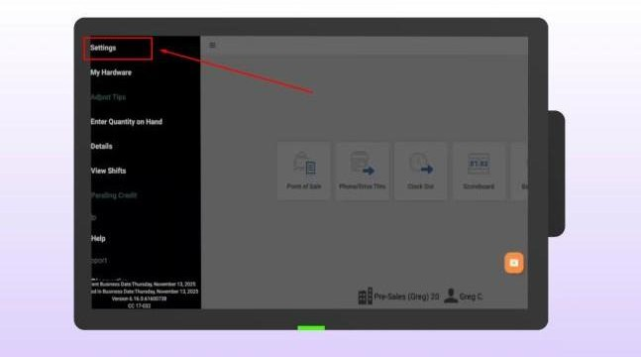

- Choose RECEIPT PRINTERS.
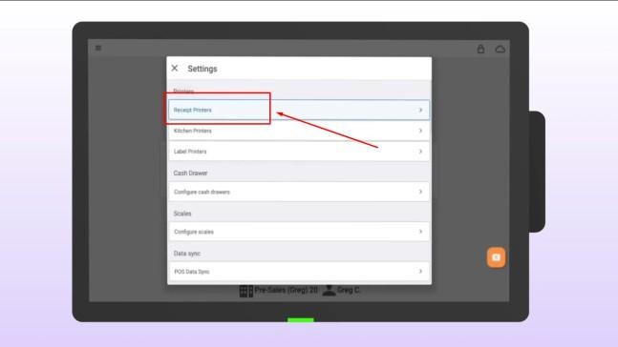

Tap ADD RECEIPT PRINTERS.
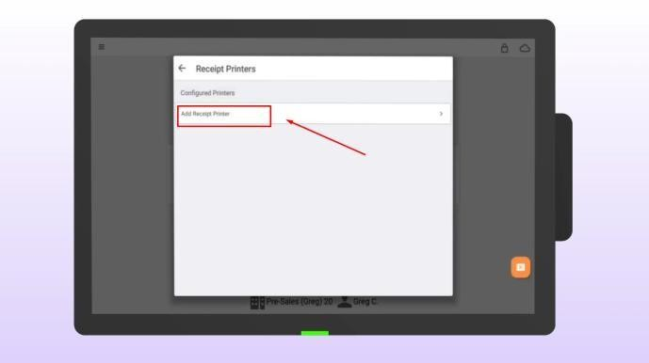
- Tap the printer's name to edit.
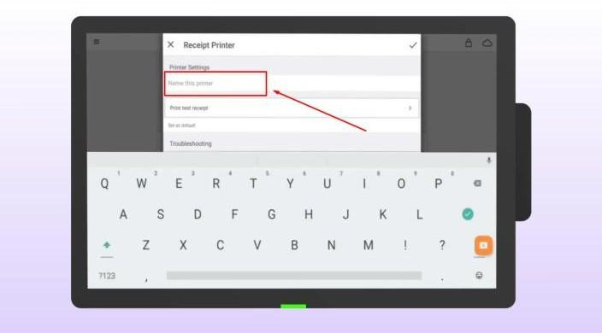

- Type a new, recognizable name.
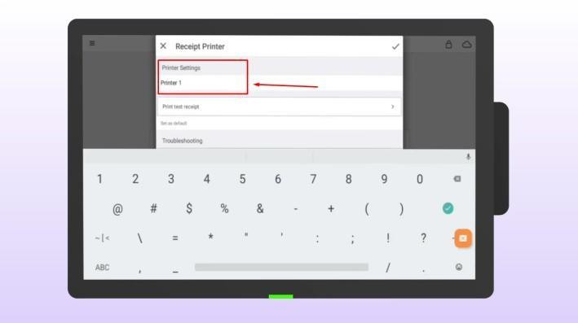
- Tap the check mark in the upper right corner.
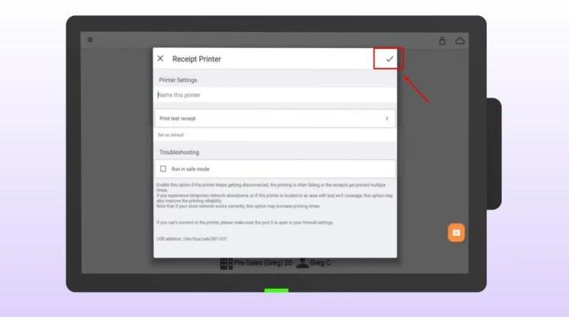

- Your printer setup is complete.

Configuring the kitchen printer (for online ordering):
Scenario: The FC needs help configuring their kitchen printer.

- Log into the AX5 point-of-sale system with your PIN.
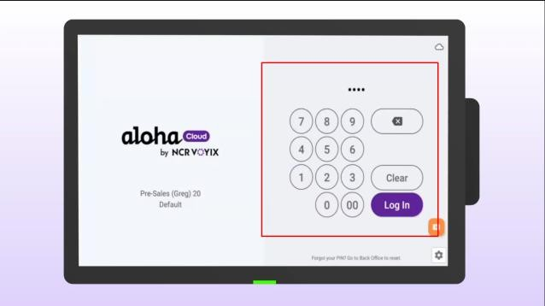
- Click the menu in the top left corner of the screen.
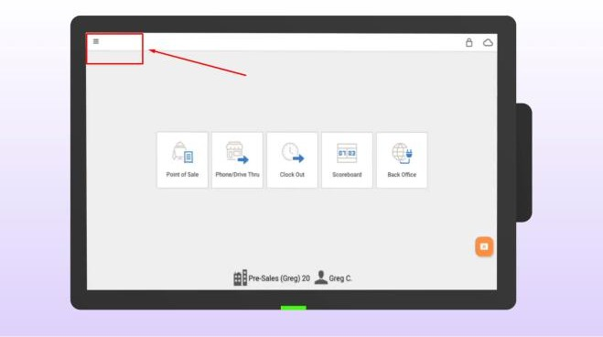
- Select SETTINGS.
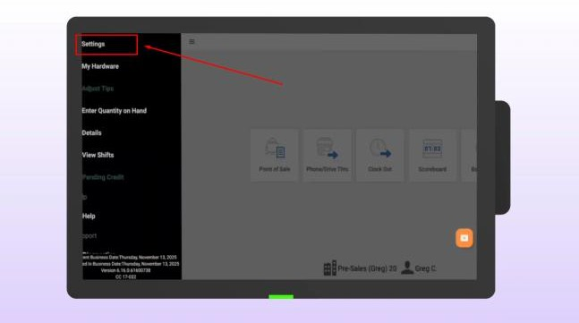

- Select KITCHEN PRINTERS.
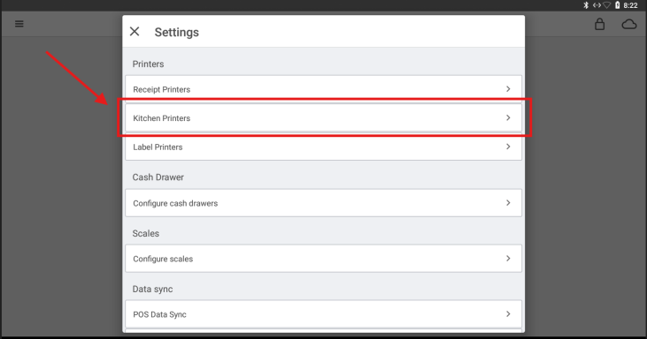

Tap ADD LOCAL PRINTER.
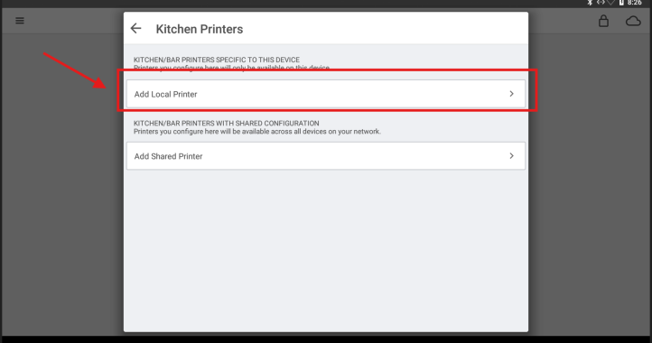
- Wait for the system to discover the printer, then tap the USB Printer option.
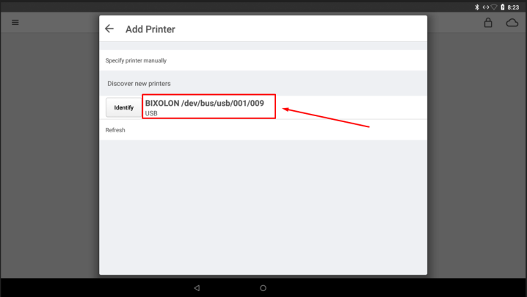

- Click "Online Printer" if this is for the Counter, or "Drive Thru Printer" if it’s for the drive-thru.
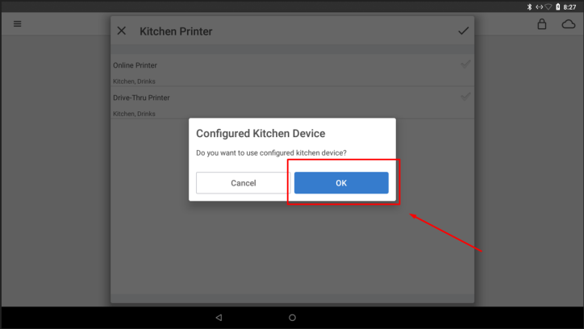
- Once you see the green check mark next to the kitchen printer that you configured, tap the check mark in the top right corner.
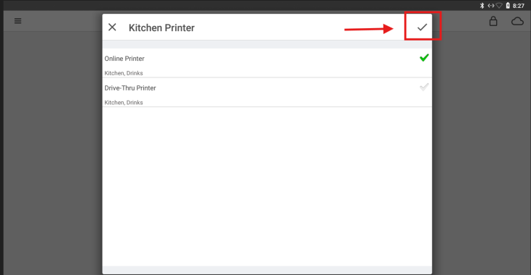

You can now read below ONLINE PRINTER: "Kitchen, Drinks". This means the system has been correctly assigned.
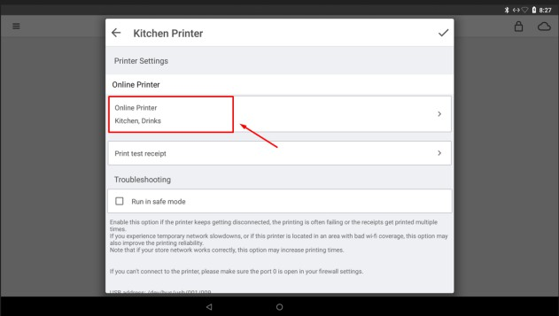

Tap the check mark to finish.
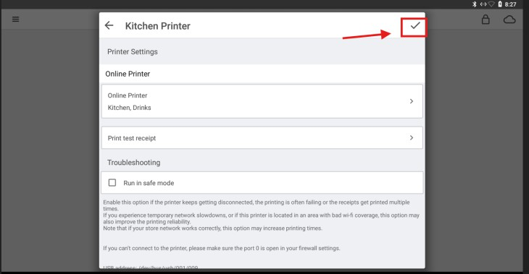

You should now see the newly installed printer under KITCHEN PRINTERS. You may now return to the main screen.
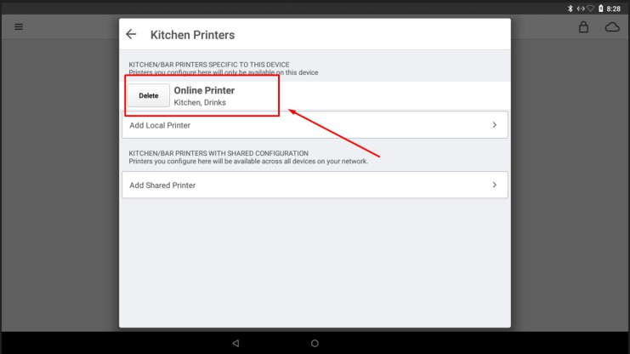

Configuring the cash drawer
Scenario: FC is emailing because they want to connect the cash drawer with the POS

- Log in to the AX5 point-of-sale system using your PIN.
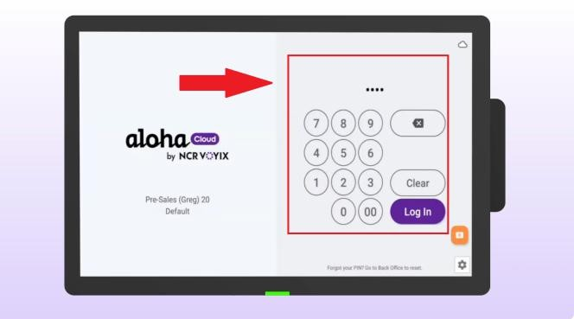
- Click on the menu in the top left corner.
- Select SETTINGS.
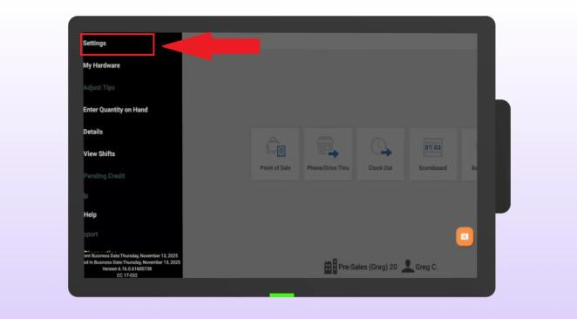
- Select CONFIGURE CASH DRAWER.
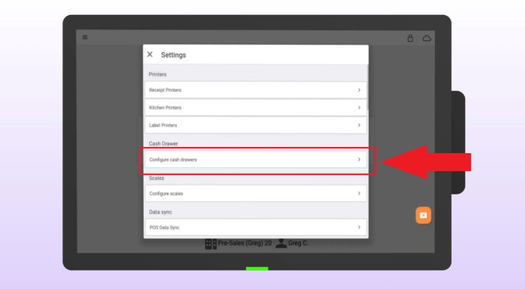

- Select POS CASH DRAWER PORT.
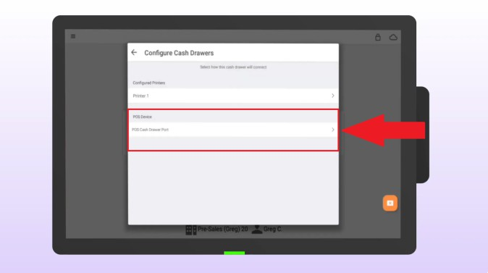
- Select CASH DRAWER ATTACHED
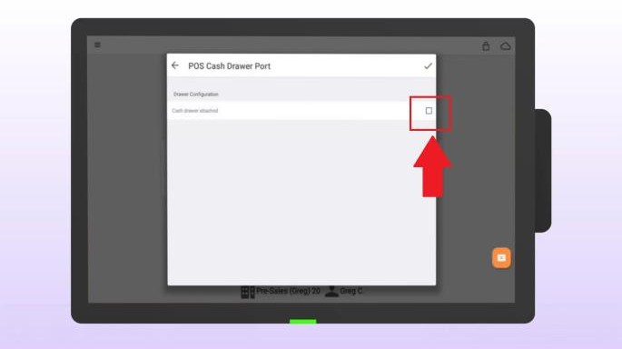
- Name your cash drawer.
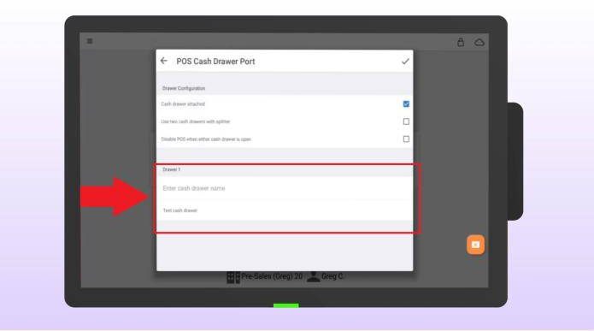
- Use a recognizable name. This name will appear at the end of financial reports at the end of the shift, e.g., "COUNTER-02."

Tap TEST to make sure the drawer opens properly.
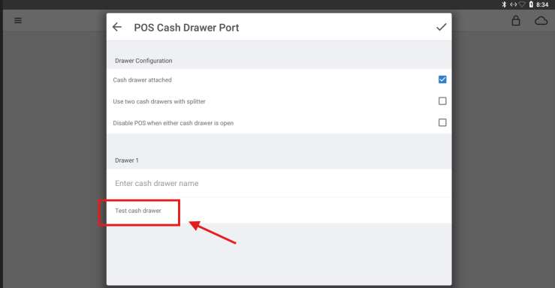
- When prompted, confirm that the cash drawer has opened by tapping YES.
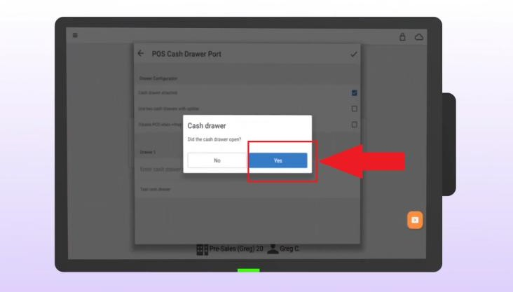

- Finally, tap the tick in the top right-hand corner.
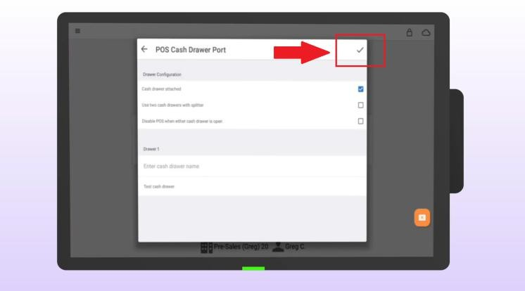
- Your cash drawer is now set up and ready to accept payment.

